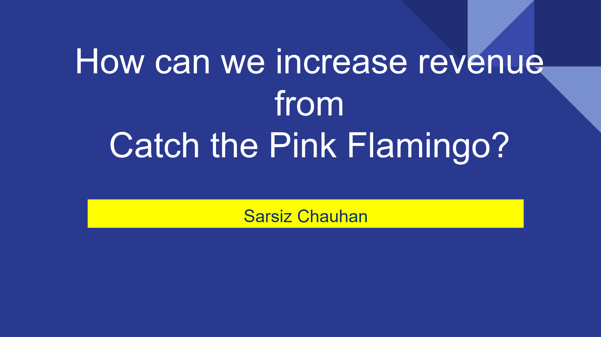

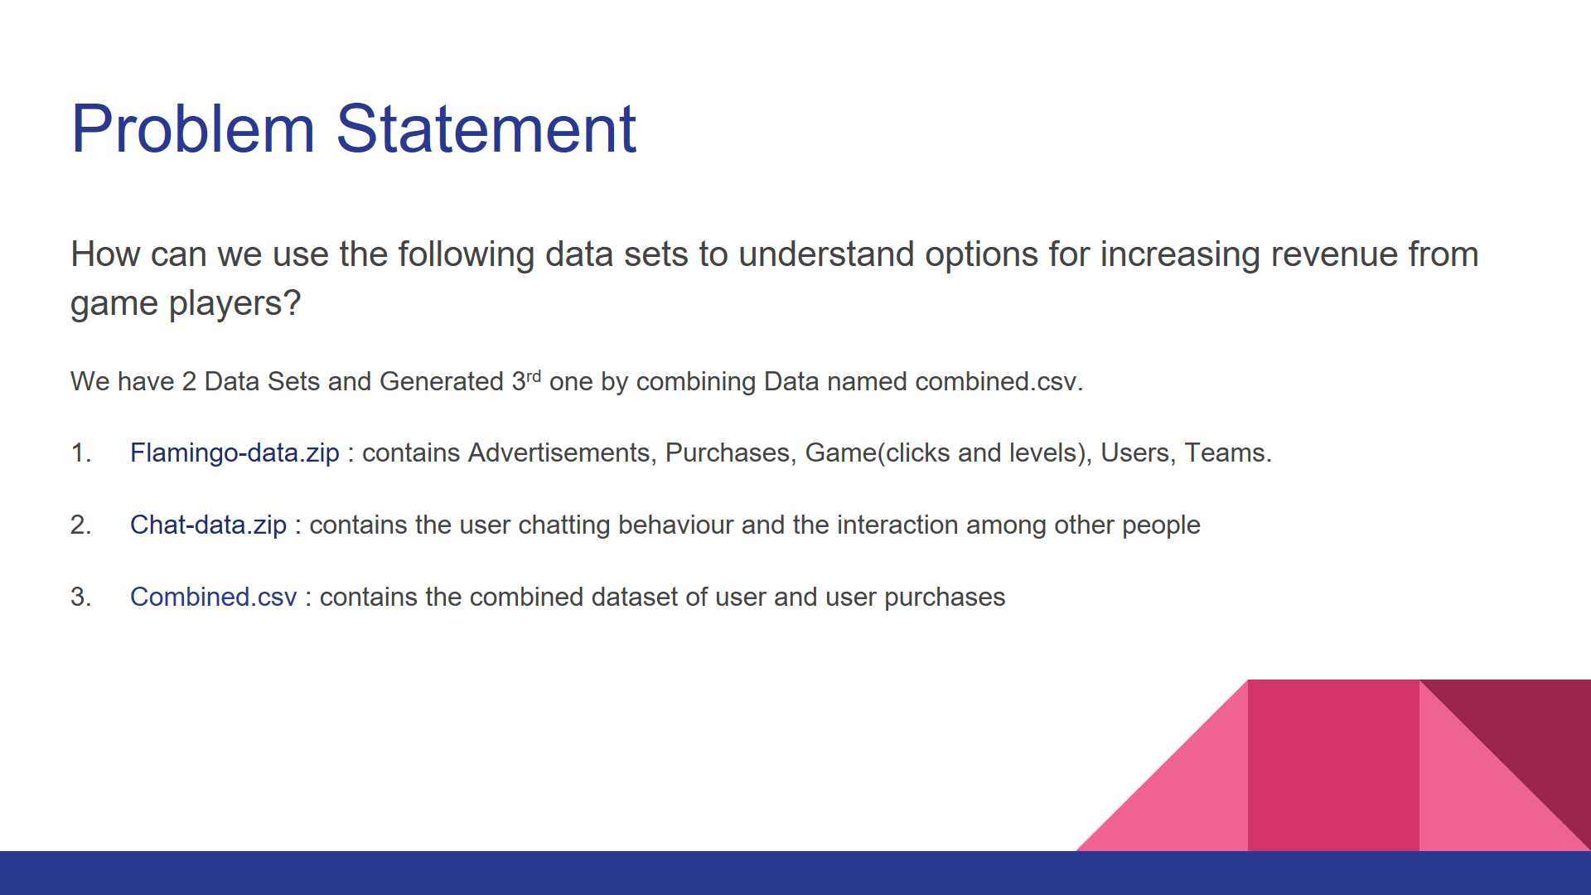

More parameters we have more accurate will be the predictions as we would have more factors to validate the data and the final insights from the data.

We studied Users Chat behaviour using the chat-data zip file and the Flamingo-data zip file for analysing the in-app purchases, team behaviour, which ads are viewed most, different levels, etc.

So different data will provide different view about the data in it and also combining the different parameters in the file can further provide us the hidden insights of data and all this done is through analytics-driven approach.

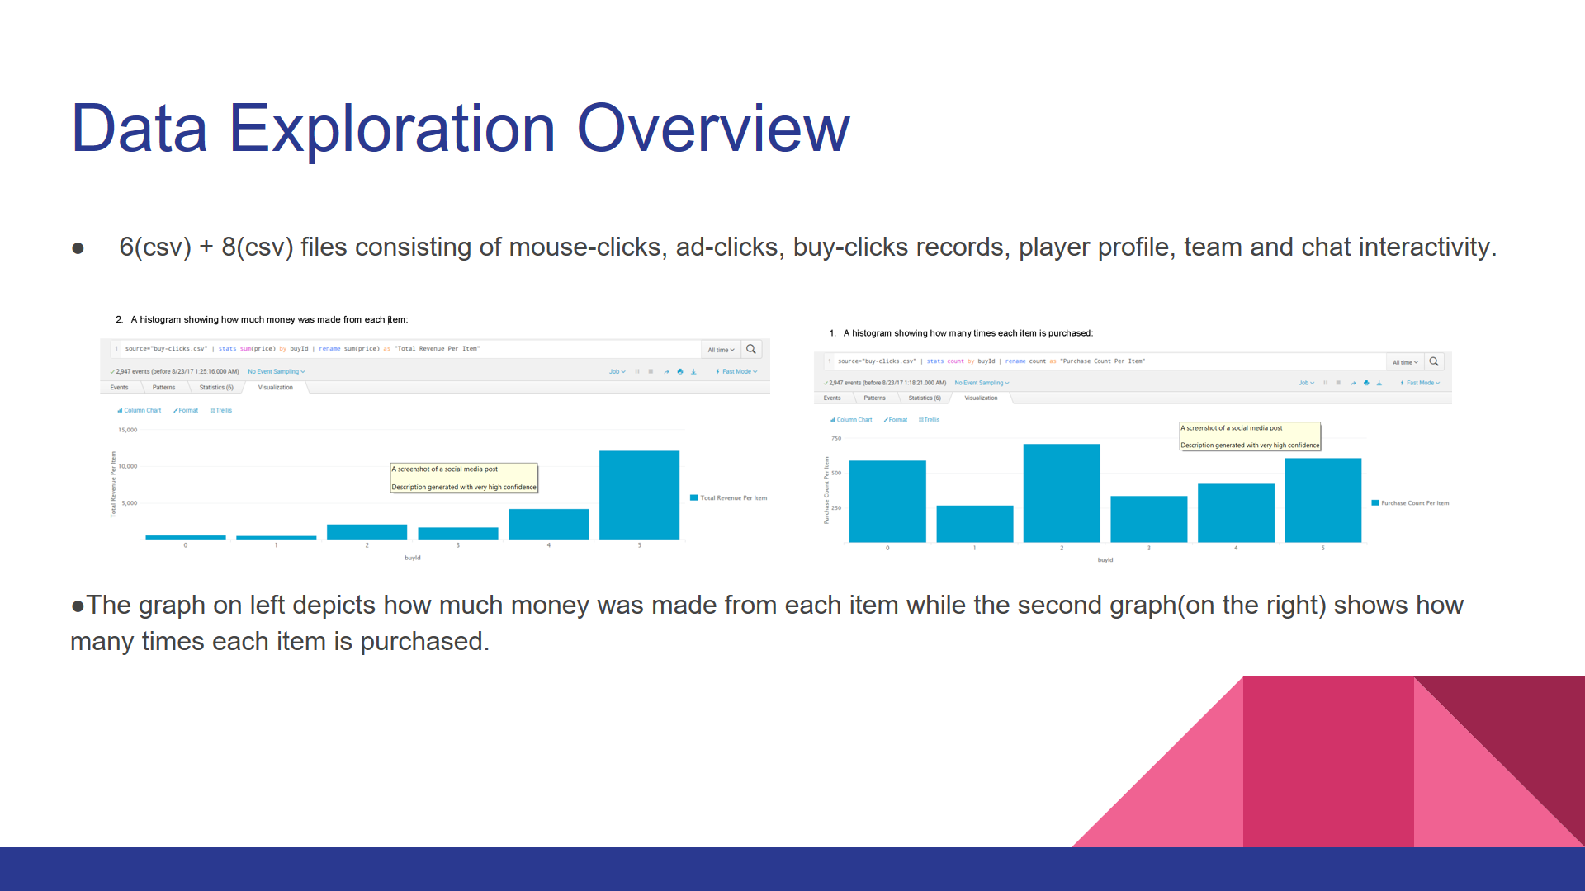

Purchase Amount Ranges from 250 to 750(as shown in the y-axis of the graph on the right) and that revenue generated from each item is from 600 to 12200(from left graph).

So, item 5 is the most expensive item and also this item is quite very popular as shown in the graph on the right(item 5). But the second item is bought more frequently than the other items.

Putting more resources in studying the impact and benefit of item 5 to understand the sentiment of why user is purchasing this item can drive up the sales. Or having some promotions on this item to sell it to more users. Developing similar products is another option.

Also we can increase the cost of the item2 as it will increase the revenue of the company. So these factors can be considered.

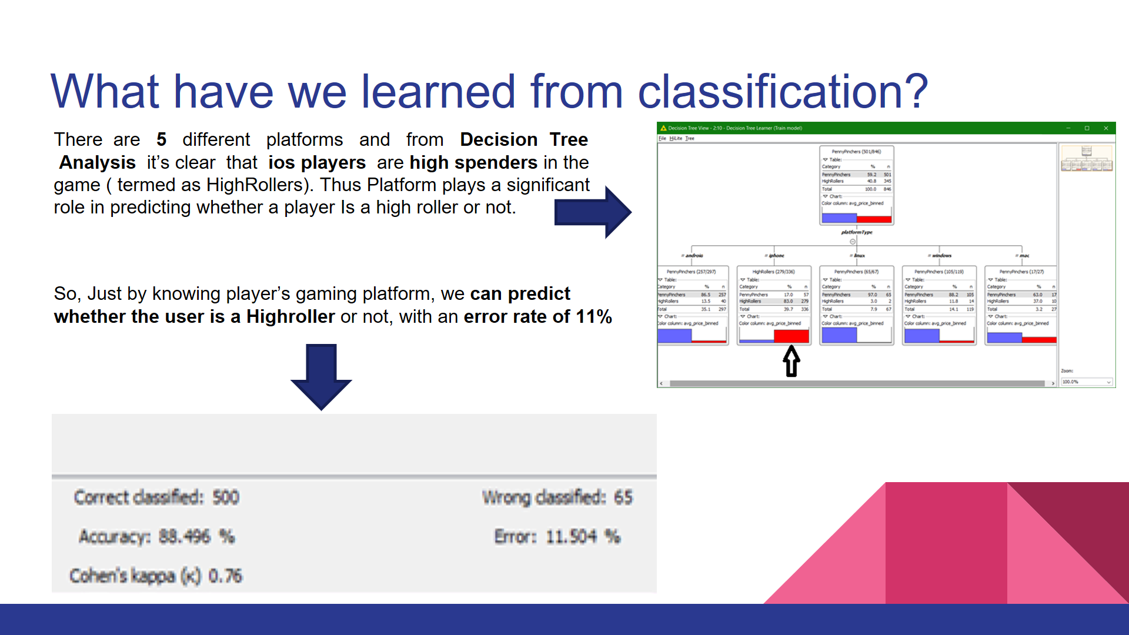

A very amusing fact that we can predict whether a user is a high roller or a penny pincher with an error rate of just over 10%.

Using different data files team-level, platform-type, game-clicks count and hit-count data, we processed all the files into the KNIME Decision Tree workflow.

Different training and testing datasets were used to train and validate our model, and findings ultimately point to platform-type as the sole factor to predict the likelihood of a player being a high-roller.

So the conclusion is that iOS platform(which is very costly itself) has very chances that their players are high rollers based on the data we obtained.

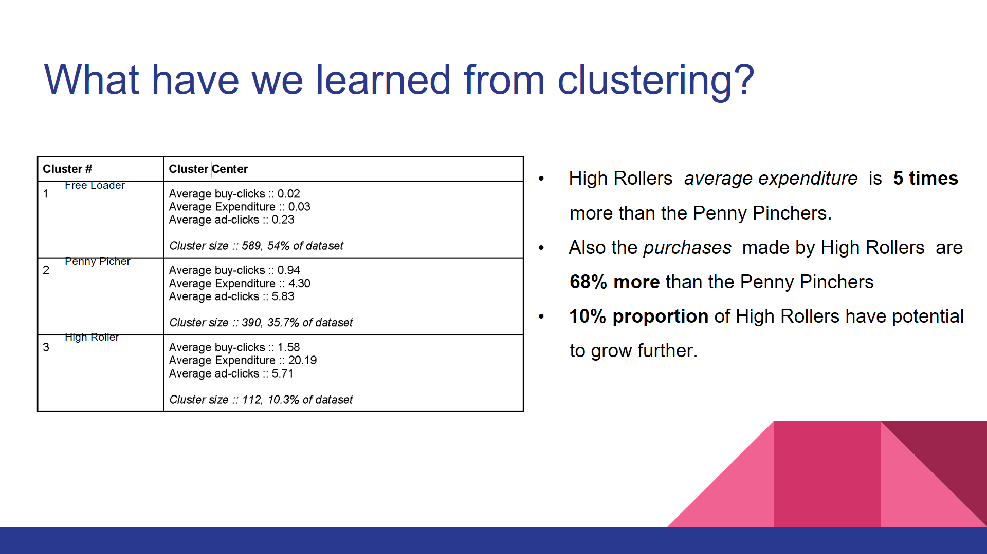

Here, we converted buy-clicks and ad-clicks into average values, and performed a K-means Cluster analysis on this transformed data set.

We found that 54% of players don’t spend at all.

Next we have Penny Pinchers, consisting of 35% of the users and almost 1 purchase is made per session, amounting $4.30 per transaction.

High Rollers consist of 10% of users and almost 1.68 times more purchases are made and spending almost 5 times more per transaction.

This should also be noted that the players who tend to buy items watch 6 times more ad than the freeloaders.

High Rollers are pretty small in number so freeloaders should be targeted in order to make them start purchasing the items by making strategies or giving discounts on different items.

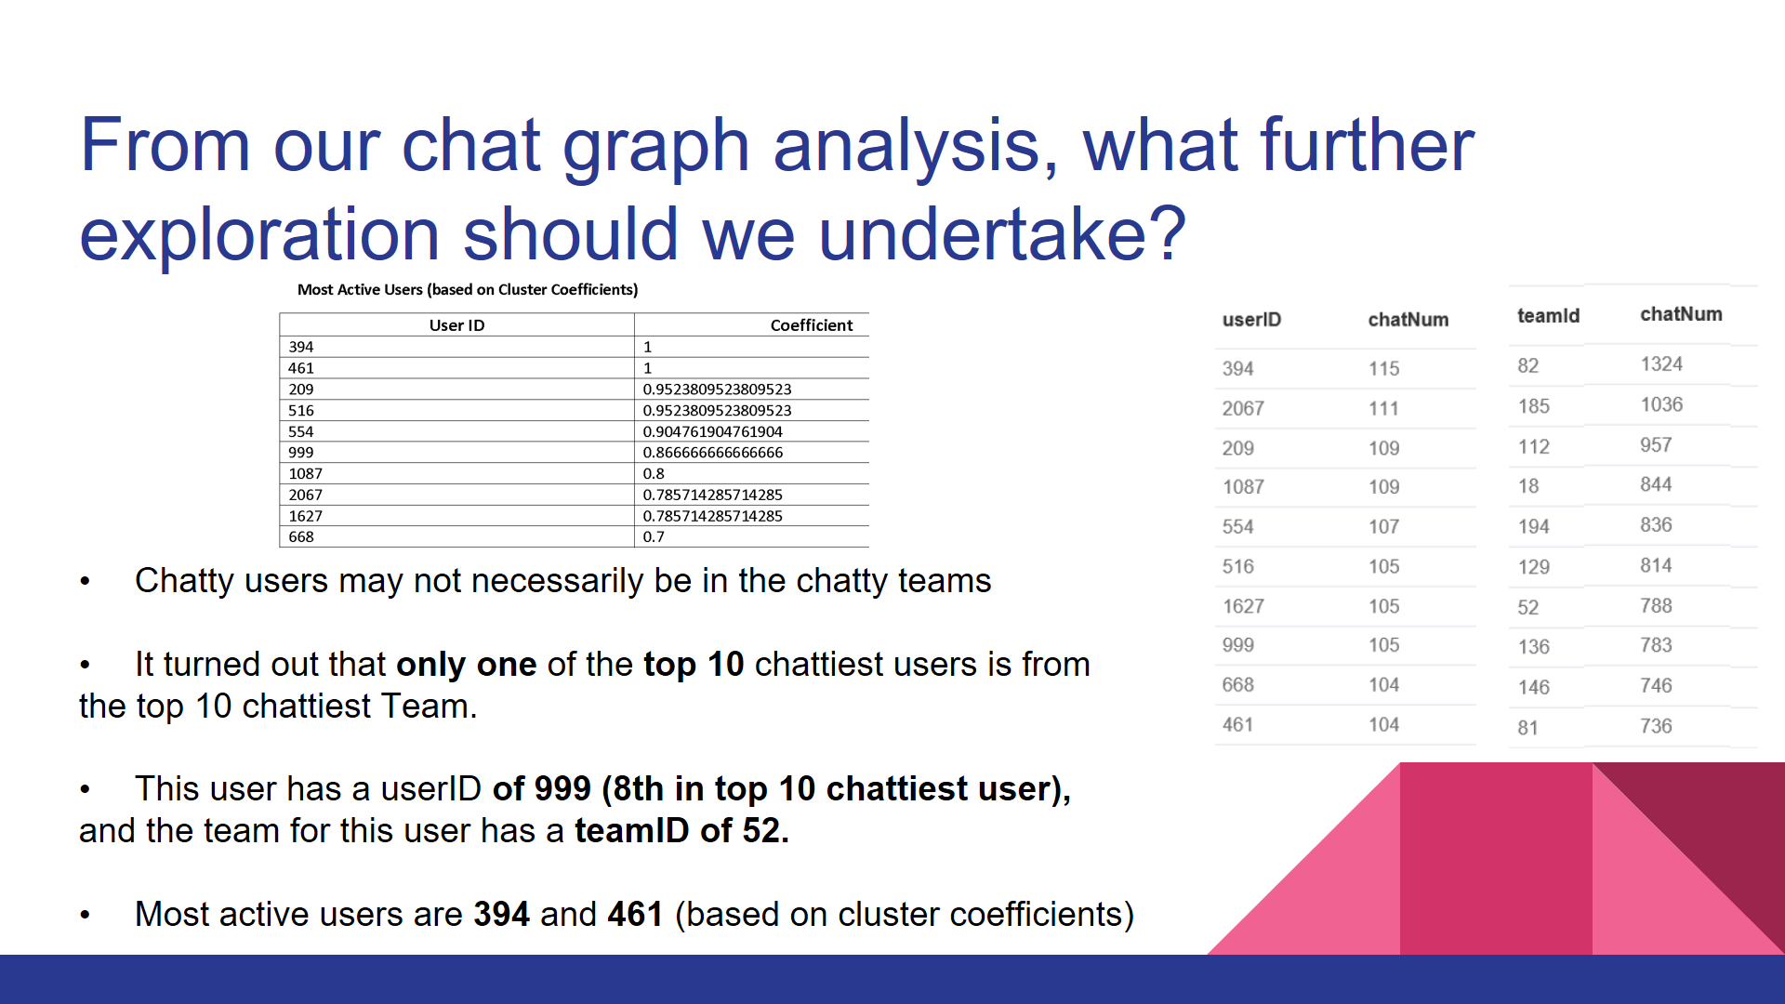

During the analysis, we found that longest conversation chain is 9(i.e 10 nodes, using Neo4j Graph Database) and the no. of users participating in this chain are 5.

Next, we found the top 10 chattiest users (Top 3 are: UserID 🡪 394, 2067, 209, 1087 last two with same number of chat items created) and similarly top 10 chattiest teams.

Then we analysed to check if any of the chattiest users are part of any of the chattiest teams and it turned out that only one of the top 10 chattiest users is from the top 10 chattiest Team.

In the end we analysed how active are group of users and we did by finding the clustering coefficient. On the top left the table is shown of the top 10 chattiest users with their Cluster Coefficients.

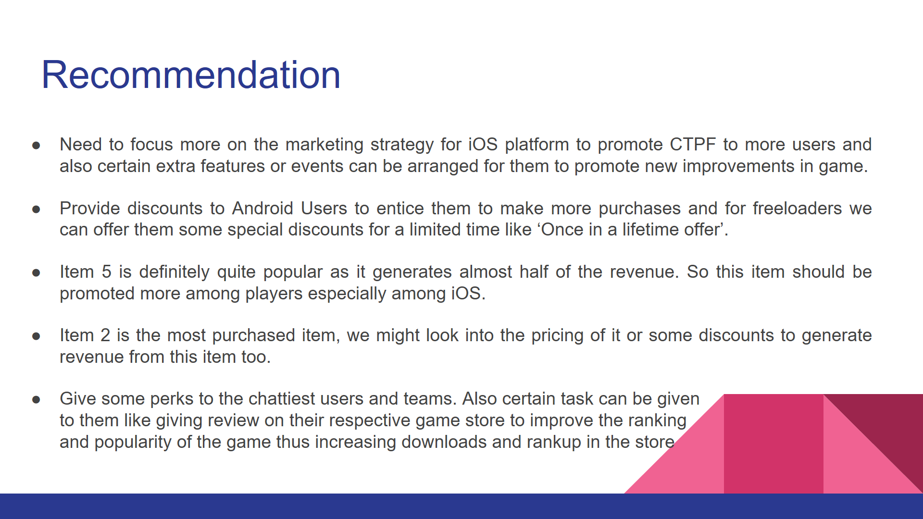

To conclude, we need to focus more on selling of item 5 by improving it more or developing more similar features for iOS users and later on releasing it to the different platforms.

Item 2 does not generate much revenue despite being purchased more than the item5. So it’s pricing needs to be revaluated to get more revenue and if it gets successful like item5 in terms of revenue then we may end up getting almost two times more revenue than before.

We can also advertise whenever a user in a team makes a purchase so that other users in the team might get influenced.

Rewarding some perks to the chattiest users and teams and assigning tasks(like giving rating, attending special events, or unlocking various achievements) to them which will ultimately help in promotion of the game